Product Information Details for Online Shop (E-commerce Site)
Supplier Name: Rokomari Butok/Society Name (Hamidpur Mahila Samity)
Contact Person Name/ Beneficiaries Name/ID: Nur-E-Nanin
Mobile No: 0198123456
Address: Rongdanu Para, Jessore Sadar

Sl. No | Product Name | Product Code | Product Picture | Buy Price | Sell Price | Product Details | Remark
01 | Naksi Katha | 1001 | 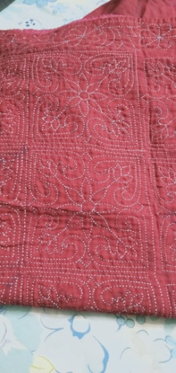 | 2500/- |  | Name: Naksi Katha,  Color: Red  Fabrics: Cotton  Size: 7’x5.5’ (Feet) | You can provide more picture of a product. Like- font view, top view, Back view etc.
02 | 3- Piece | 1002 | 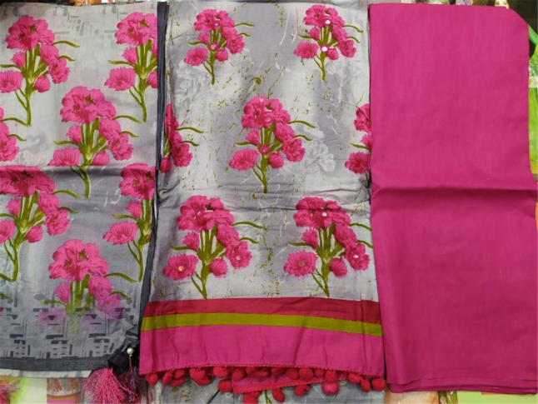 | 1800/- |  | Name: 3- Piece  Color: Mixed  Fabrics: Suti Dupatta  Free Size | You can provide more picture of a product. Like- font view, top view, Back view etc.
… | … | .. | .. | .. | .. | .. | ..

